Jeremy Maniago

ME 572 – Aerodynamic Design

Professor Yang Liu

# Project Progress (Project Assignment 2)

## Project Summary Recap

The project aims to develop code that simulates and visualizes elementary potential flows. Using the known elementary flows, we can use MATLAB to set up and solve for the velocity fields and streamlines produced as an effect of singular or multiple combined potential flows.

## Achievements

As of 05/01/24, a plot showing the velocity field along with streamlines of 3 elementary flows was achieved in MATLAB. Uniform, Source, and Sink flow was successfully simulated, with the ability for the strengths and locations of the source/sink flows to be configured. Additionally, multiple potential flows were simulated, including uniform + source, uniform + sink, and uniform + source + sink (otherwise known as a Rankine Oval). The Rankine Oval visualization is shown in **Figure 1**.

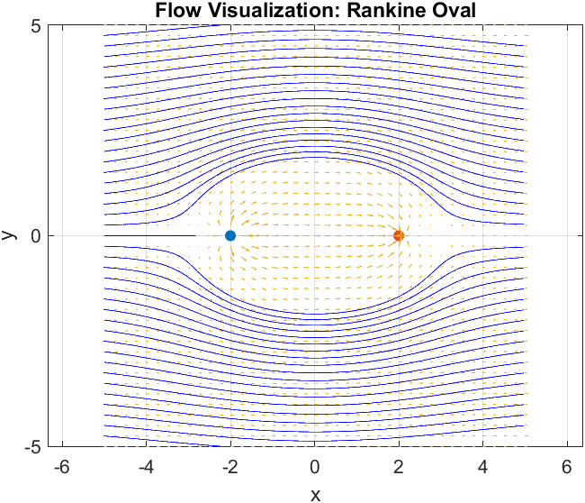

Figure 1: Rankine Oval visualization in MATLAB

## Tasks Completed

* Velocity Field Vectors plot
* Uniform Flow
* Source Flow
* Sink Flow
* Combined flows
  + Uniform and Source
  + Uniform and Sink
  + Uniform, Source, and Sink (Rankine Oval)
* Initiation of symbolic variables used to perform symbolic math such as indefinite integration

## Tasks Todo

1. Make separate functions for each elementary flow for efficient callouts and code. Will make large multiple flow combinations more possible and organized.
2. Create a new streamline function (move away from built-in MATLAB function).
   1. Simplify symbolic math (indefinite integration) performed on the *u* and *v* velocity vector components
3. Find method of calculating stagnation point(s) in different flows, as well as plotting the streamline that passes through said stagnation points.

## Challenges and Issues

Lack of intuition of stream functions has slowed progress. Luckily, there is a differential form of a streamline function, but indefinite integration must be performed which only makes the code messy. The stagnation calculations will also be difficult as it involves solving with algebra – another task possible with the symbolic math toolbox. There is also a lack of physical interpretation in terms of scale due to lack of units, but that can be addressed later on if a possible future task involving calculations such as circulation and lift is reached.

## References

1. Professor Yang Liu’s ME 572 Lecture Notes